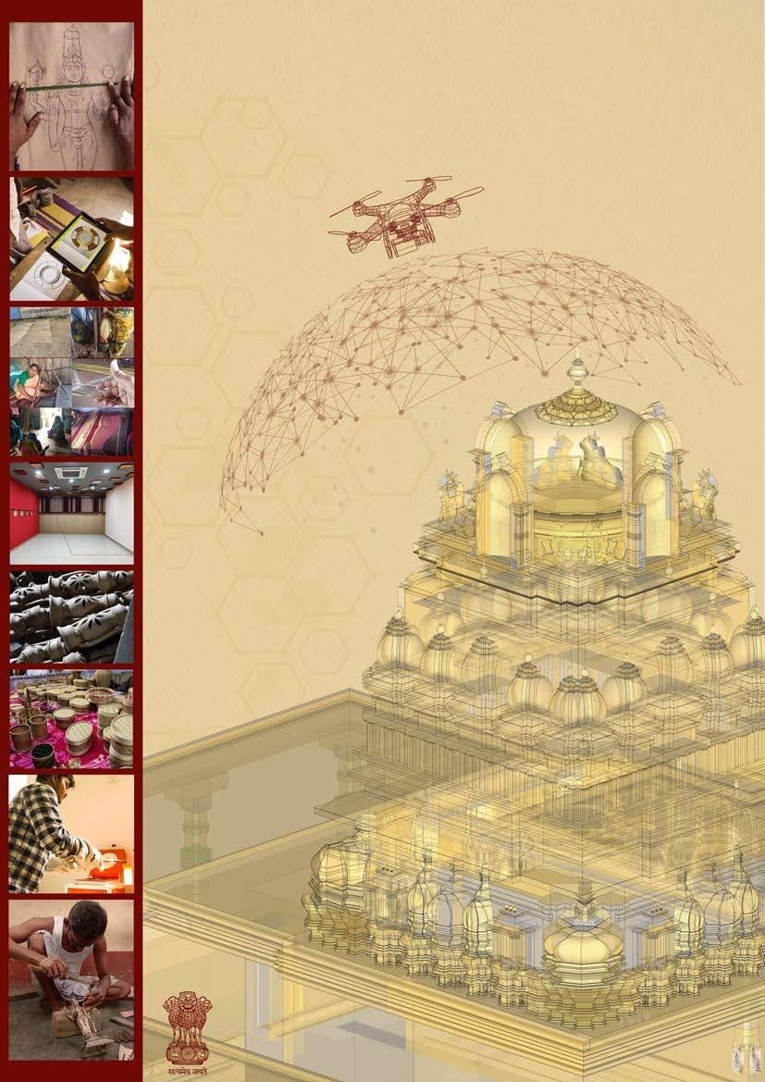
SCIENCE & HERITAGE RESEARCH INITIATIVE
(SHRI)

Government of India
Ministry of Science & Technology
Dept. of Science & Technology
(Technology Development Programme)

GUIDELINES & FORMAT

FOR SUBMISSION OF

PROJECT PROPOSALS

UNDER THE SCHEME

“SCIENCE & HERITAGE RESEARCH INITIATIVE (SHRI)”

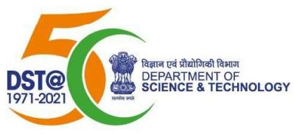

GOVERNMENT OF INDIA
MINISTRY OF SCIENCE & TECHNOLOGY
DEPARTMENT OF SCIENCE & TECHNOLOGY
TECHNOLOGY BHAWAN, NEW MEHRAULI ROAD,
NEW DELHI- 110 016

Science and Heritage Research Initiative (SHRI)

Scheme: Technology Development and Transfer
Background:
Heritage is our most precious inheritance through culture, nature, architecture and humanity itself. The term includes tangible heritage like historic monuments, archeological settlements, artifacts, etc. as well as myriad intangible layers such as oral traditions, rituals, social practices, native games, performing arts and a wealth of hereditary knowledge and skills. An ancient civilization like ours is completely rooted in such enviously deep intangible wealth that is unfortunately fast disappearing due to insufficient recognition and prioritization. Despite worldwide acclaim over centuries, listing of our intangible heritage is still in a nascent stage.
The science of heritage management holds the key to preserving this fragile wealth of identity and continuity despite diverse scientific challenges. As heritage is not just a past memory, but also a living and evolving entity, the challenge requires us to continue creating heritage in order to preserve it. A holistic approach is required including extensive documentation, study of history, materials and technologies across eras, understanding aging and degradation processes, assessing and grading the current state of entities, etc.
In the modern era, heritage and science have been pushed to opposite ends in the research and innovation domain. This gap had brought about a huge vacuum of modern technology and enterprise in heritage preservation. However, in the past couple of decades, Science and Technology has been playing an important role in the development of new materials, innovative tools and methods for better investigation, preservation, conservation and restoration of tangible and intangible heritage. Its significance has grown steadily, especially in culturally rich, knowledge-based economies. Cutting-edge collaborative work of chemical science and other research teams, especially in analytical, organic, environmental chemistry, electronics and computer science, has brought in new tools and methods for greater precision in analysis, diagnosis and preservation of art & culture. Keeping in mind that heritage is a time sensitive challenge; rapid interventions through synergetic explorations seem to be the best way forward.
Despite such developments internationally, India appears to be falling back in the struggle to recognize and preserve our heritage – a fundamental key to a healthy society. Social cohesion, involved communities and pride in distinct identities are some of the core benefits of successful preservation efforts. The quality of space and human life has been woven in the form of heritage and culture over the years, that in the face of impossible odds, it is desirable to sustain a living heritage, then to let it pass down as a memory.
Overview:
Over the last few centuries, innumerable historically significant settlements have changed beyond recognition due to various growth factors, disadvantageous economic concerns as well as sheer ignorance. While every change continues to weave heritage differently, it is also essential to scientifically gauge and maintain certain identities and characteristics synonymous with the area and community. History, despite its lost roots, cannot be unlived, and it is advantageous in all ways to bring it back to life by restoring societal connections with cultural heritage.
Heritage vitally needs to be noticed spatially and concerns in this regard need to be primarily addressed. However, duplicative physical rebuilding in select spaces alone is inadequate. All the intangible aspects concerning the space also need to be deeply understood and considered. Spatial narratives, ritual manifestations, symbolic interpretations, kinesthetic calibrations, natural and local phenomena; all need to be studied in the larger picture, if the goal is to retain the true spirit and essence of the legacy.
Heritage preservation and valorization of legacy may be vastly augmented through scientific methods and technologies, thereby converting it into a resource. The imaging, diagnostic, and preservation techniques for cultural heritage and the expansion of tool making options can be optimized through interdisciplinary collaboration and technology transfer whilst inspiring researchers to explore beyond boundaries.
Science & Heritage Research Initiative (SHRI) is a scheme for Heritage Research, aims to engage experts from diverse fields for data capture and analysis, to form new collaborations, and provide viable technology, to address cultural heritage related issues.
Aims and Objectives:
The SHRI has been envisaged to:-
- Understand and document the Science and Technology behind the Heritage.
- Build capacity in human resources, and encourage new researchers to work in these areas.
- Promote scientific R&D activities, for conservation of Heritage objects which may include material deterioration process, preservation techniques, intervention technologies, new materials, processes for restoration and diagnostic technologies along with actual field application.
- Safeguard the use, representations, expressions, knowledge and techniques, communities, groups, and in some cases individuals, recognized as an integral part of our cultural heritage.
- To explore new approaches, state-of-art technology, to preserve the heritage and ancient art works which witnessed the evolution and growth of human civilization.
- Promote application of advanced knowledge of archaeometry in a range of fields.
- Promote R&D activities and technological advancement in Tribal Arts for value addition.
- Develop Heritage Entrepreneurship Models to bring Economic and Social changes
- Promote traditional food practices
- Identify and establish backward and forward linkages for sustainable propagation of the heritage techniques, practices and products
Scope:
To broadband the research activities, with a strong focus on the relationship between tangible and intangible culture, and to explore intervention techniques, to promote, and enhance heritage science innovations, and contributions of our rich heritage, towards the culture and the economy of the Nation.
The envisaged thrust areas are:-
- Physical Space for Heritage
- Study & Identify the potential heritage sites using the latest scientific principles like GPR, Lidar, and Rescue Archeology.
- Radio Carbon Dating and protection of heritage objects/sites
- Testing and survey of heritage sites using Digital photogrammetry and Terrestrial laser scanner.
- Development of New Digital instruments such as BIM, GIS …etc for knowledge, analysis and protection of heritage
- Landscape indicators and data model proposal for a GIS based heritage management system
- Laser Remote in situ spectroscopic diagnostics of the heritage objects
- Risk assessment and monitoring of the cultural heritages(Pollution, Climate Change, Natural Events, Micro Climate )
- Digital Space for Heritage
  - Fusion of 3D digitization technologies for virtual exploration: Virtual Reality, Augmented Reality, Mixed Reality and Giga pixel Image technologies
  - Architectural heritage information in 3D Geospatial model
  - Digital Library/Museum Protection of Manuscripts
  - IT Platform for Indian Heritage – through Crowdsourcing
  - Remote Sensing
  - Manuscript Digitization
- Technologies for Textile Heritage
  - Kinematic Designs & Dynamic Analysis
  - Prototyping and Optimization of Looms
  - Heritage Textile & Dyes
  - Technologies for traditional fibers
  - Traditional yarn treatment, weaving, printing, eco-friendly dyes, cement clothing
- Traditional Agricultural Practices
  - Sustainable & Traditional Agricultural Practices
  - Protection of architectural heritage in agriculture landscapes
  - Gene banking for traditional seeds
  - Traditional pest control techniques
  - Traditional irrigation management
  - Traditional storage technologies/practices for Agri products
  - Revival of traditional animal husbandry practices.
- Technologies for Tangible Heritage
  - Study of Traditional Music and Folk Instruments
  - In-situ non-invasive imaging of sub-surface microstructure of object, sustainable radiography for heritage materials
  - Conservation of Metallurgical practices
  - Shilpa Shastra
  - Conservation technologies, tools and practices of tribal heritages
  - Study of physiochemical properties of heritage materials, protein identification in cultural Goods
  - New material development for heritage conservation and preservation (Development of restoration mortars with improve functionality at low temperature, conservation material coating, Nano restore Gel,Nano Biocide ..etc)
  - Geospatial (Remote sensing, GPS, GIS and GPR) based cultural infrastructure development and heritage management.
  - Developing heritage zones: Heritage entrepreneurship models to bring economic and social changes; application and demonstration of established heritage practices and techniques.
- Technologies for Intangible Heritage
  - Preservation of Tribal medicinal practices, heritage, and culture
  - Living Heritage and kinesthetic
  - The economic revival of heritage cultural practices by establishing backward and forward integration and market linkages for the sustainability of the heritage.
  - Study and scientific documentation of location specific martial arts

Any other areas related to Heritage other than mentioned above, any specific skill development programme to create trained manpower on heritage technologies or practices, any specific studies to understand the scientific phenomenon behind degradation and preservation
.Beneficiaries:
Depending on the objectives of the activities specified in the call for proposal, launched from time to time, the projects could be proposed by:
1. Academicians and scientists working in public/private/ voluntary sector, S&T based voluntary organization;
2. Academic and R&D Institutions, State Government bodies such as S&T Councils, Autonomous bodies working in Heritage sector; and
3. Network of individuals/ institutions will be considered favorably in the event where project activities require multi-disciplinary multi-institutional participation. Several such possible options could include research work, by academic/R&D institutions in association with Industry/ NGO, demonstration in consortia mode involving R&D institution/industry/NGO, state government line departments, S&T field groups and local panchayats.
In case of heritage practices and products the stakeholder participation is essential.
Coverage Area:
The Initiative envisages implementing the programme throughout the nation.
Timeline:
Proposals under SHRI will be entertained only against specific calls. The priorities and commitments of the SHRI, will be articulated in the “Call for Proposals”, which would appear on DST website after specified intervals. The criteria for evaluation and evaluation procedure will be part of call document. Interested applicants may apply against the call. However, the next phase of projects supported earlier, which are essential for logical conclusion of the project, will be considered beyond the call domain.

GUIDELINES FOR FORMULATING PROPOSALS
- The proposal should clearly establish linkage of S&T to Cultural Heritage.
- DST encourages formulation of proposals through consultative process. Preliminary proposals giving brief information on concept, idea, proposed activity etc. may also be submitted. These preliminary proposals could be further refined through mutual discussions, expert advice etc.
- The proposals should be based on innovative technologies/ ideas, and the training programmes should be on specific technologies/ themes. Routine training programmes will not be entertained.
- Proposals should have specific, concrete, quantifiable objectives and deliverables.
- Methodology should be very clear. Preliminary work in the similar area with support of the proposed work need to specify
- The proposal objective may be oriented to few specific outputs, which could be possible in duration of 18 to 36 months (max).
- The scientific and technical details should be clearly spelt out.
- Results of ongoing and completed projects of the organization must be reflected while formulating new proposals.
- User Industry participation and contribution is encouraged
Any correspondence/ queries may be communicated to the shri.dst@gmail.com. The proposal will only be accepted via online mode through ePMS (https://onlinedst.gov.in/)

Dr. Neeraj Sharma
Adviser & Head
Technology Development and Transfer
Department of Science & Technology, Ministry of Science and Technology
Technology Bhawan, New Mehrauli Road
New Delhi 110 016

LAST DATE OF SUBMISSION: JULY 31, 2021
GENERAL TERMS AND CONDITIONS
- The Principal Institution assumes financial and other administrative responsibilities of the project.
- In case of multi-institutional project, formal agreement from the collaborating institutions/ scientists should support the proposal.
- International travel is not permissible under the project.
- The manpower recruited for the project should be paid as per the rules of the Institute/ the guidelines of the Government of India. The posts which are not covered under the guidelines but permissible under projects at host institute are also permitted.
- The temporary staff employed for the project by the organization is not treated as employees of Government of India and the deployment of such staff at the time of termination of the project will not be the concern / responsibility of the Government of India.
- The proposals will be considered for approval/rejection by the Scientific Advisory Committee (SAC) in DST. The group may seek expert opinion, wherever required.
- It is the policy of DST, to maximize the use of equipment. In this light, Investigator shall permit the use of spare or idle capacities of equipment, procured under the project by Bonafide users (research workers in other DST funded projects or other projects of the institute).
- All the assets including equipment acquired and prototypes fabricated from the grant will be the property of Government of India and should not be disposed of, or utilized for purposes other than those for which the grant has been sanctioned, without the prior sanction of the Department of Science & Technology.
- The Comptroller and Auditor General will have the right to access to the books and accounts of the organization for Grants received from the Government.
- The organization would maintain separate account for the project. The grant should be kept in an interest earning bank account and the interest earned should be reported to the Department of Science & Technology. The interest thus earned will be treated as a credit to the organization and will be adjusted towards further installments of the Grant.
- The Principal Investigator / organization will prepare all the documents that would be required for the transfer of know-how to the production agency/agencies and submit them of DST as and when required. The organization will be responsible to transfer the know-how developed to the production agency/ agencies and supply all the needed information to the production agency/ agencies as and when required.
- The know-how generated from the project would be the property of the Government of India and any receipts by way of sale of know-how, utilization of know-how for production, royalties etc. shall belong to the Government of India. The Government of India, may, at its discretion, allow a portion of such receipts to be retained by the organization.
- Sale proceeds, if any, of the components, prototypes, pilot plants etc. fabricated as a result of the development of the project arising directly from funds granted by the Department of Science & Technology shall be remitted to the Government of India. The Government of India, may, at its discretion allow a portion of such receipt to be retained by the organization.
- Grant can be terminated by DST at any stage if it is convinced that the Grant has not been properly utilized or appropriate progress is not being made.
DOCUMENTS/ENCLOSURES REQUIRED WITH THE PROPOSAL:
- Endorsement from the Head of the Institutions (on letter head) and Certificate from Investigator(s)
- Details of the proposal
- Name and address of experts/Institutions, who may be interested in the subject/outcome of the project (circulation list).
- Registration Certificate, Memorandum of Association, and Rules and Regulation of the Institution.
INSTRUCTION FOR FILLING UP THE PROFORMA
- Please type as per the layout given in the format.
- Please do not skip reproduction of any section even if the answer is “nil” or given elsewhere.
- Project title should be precise, and should not exceed normally 20 words within two lines.
- Expected total duration of the project should normally be 18 months, and in no case should exceed 36 months.
- If project is to be executed by more than one institution /States (which is welcomed) and /or requires regular inputs from other scientists, names of collaborating institutions/scientists/ State S&T Councils may be listed.
- Use telegraphic language to the maximum extent possible for objectives, work plan, methodology, expected outcome etc.

FORMAT FOR SUBMISSION OF PROPOSALS
“Science and Heritage Research Initiative (SHRI)”

(To be filled by Project Investigator)

IDENTIFICATION
  - Project title

……………………………………………………………………………………………………………….………………………………………………

Key Words ………………………………………………………………………………

2. State: ……………….

- Broad Area: - (Please tick mark (√)
  - Physical Space for Heritage ( )
  - Digital Space for Heritage ( )
  - Technologies for Textile Heritage ( )
  - Traditional Agricultural Practices ( )
  - Technologies for Tangible Heritage ( )
  - Technologies for Intangible Heritage ( )
  - Specific studies to understand the scientific phenomenon behind the degradation and preservation ( )
  - Skill Development Programme ( )
  - Other Areas ( )

- Duration: (number of months)

- Total Cost: Recurring Non-recurring

- Principal Investigator:
  - Name:
  - Department
  - Designation
  - Organization/ Institution Name:
  - Address (Including Telephone (Off & Res), E-mail, Fax) Pin:
  - Date of Birth
  - Sex (M/F)
- Co-Investigator:
  - Name:
  - Designation:
  - Department:
  - Organization/Inst. Name:
  - Address: (Including Telephone (Off &Res), E-mail, Fax), Pin:
  - Date of Birth:
  - Sex (M/F):

- Capability of the Organization:
- Expertise available:
- List of on-going and completed projects giving the following details:

Project Title | Start Date | Completion Date | Project cost | Sponsoring organization

TECHNICAL DETAILS
  - Background
    - Description of problem
    - Review of work already done
    - Rationale for taking up the project
    - Relevance to Heritage Science.
    - Financial resources committed at Host Institute/Industry (if any)

  - Challenge & Constraints
(Please identify strengths and weaknesses of the implementers vis-à-vis current project in terms of technical expertise, team building, past record etc. Also list the perceived opportunities and threats and describe how PI/Organization proposes to capitalize on them or avert them.)

  - Description of Proposal
    - Objectives of the project. (Brief and to the point)
    - Preliminary Investigations done by organization. (if any)
    - S&T component in the project.
    - Linkage with S&T Instts./NGO, s/resource persons/ R&D organization/ Industry for technical backup.
    - Other organizations working in this area
    - Methodology detailing stepwise activities and sub-activities.

  - Work Plan
(Phase-wise plan of action up to post project activities detailing time schedule Milestones may clearly be indicated. PERT/GANTT chart may be attached.)
  - Output of the Project
(Attempt may be made to quantify output in measurable parameters.)

  - Likely Impact (Please attempt to quantify in terms of Social & Economical)

  - Parameters for Monitoring effectiveness of project

  - Detailed Plan of Post Project Activities for the way forward

  - Status of the proposed or similar work (National & International)

BUDGET ESTIMATES: SUMMARY

BUDGET
S. No | Item | 1st Year | 2nd Year | 3rd Year | Total
A. | Recurring
 | Salaries/ Wages
 | Consumables
 | Travel
 | Other Costs (if any)
B. | Non-Recurring Permanent Equipment
Grand Total (A+B)

- Financial Year: April to March.
- Count six months from submission of the proposal to arrive at expected time point for commencement of the project.
- Please provide brief justification for each head (100 words for each).

BUDGET FOR SALARIES/WAGES

Designation (number of  persons) | Monthly Emoluments --------------------------------------------- |  |  | Total
 | 1st yr. | 2nd yr | 3rd yr. | (m.m.)*
Full time
i)
ii)
Part time i)
ii)
Total
- m.m. man months to be given within brackets before the budget amount.

BUDGET FOR CONSUMABLES

Items  Name & Quantity | 1st yr. | 2nd yr | 3rd yr. | Total Budget  (In Rupees) | Justification
Total

BUDGET FOR TRAVEL

Items  Name & Quantity | 1st yr. | 2nd yr | 3rd yr. | Total Budget  (In Rupees) | Justification
- Local Travel
- Outstation
 |  | .
Total

BUDGET FOR OTHER COSTS

Items  Name & Quantity | 1s yr. | 2nd yr | 3rd yr. | Total Budget  (In Rupees) | Justification
- Contingencies
- Others
 |  | .
Total

BUDGET FOR PERMANENT EQUIPMENT

Items  Name of Equipment | 1st yr. | 2nd yr | 3rd yr. | Total Budget  (In Rupees) | Justification
 |  | .
Total

D.PROFORMA FOR BIODATA OF INVESTIGATORS
- Name:
- Date of Birth:
- Institution:
- Whether belongs to SC/ST:
- Academic career:
Professional career:
- Award/prize/ certificate etc., won by the investigator:

- Publication (Numbers only):

Books Research Paper, report General articles

Patents Others (please specify)
- List of completed and ongoing projects
Sl. No. Title of project Duration Total cost Funding Agency
From To

- Projects submitted
Sl. No. Title of project Name of Organization Status

(Name & Signature)

Date……………………..

Place…………………….

Annexure-I

ENDORSEMENT FROM THE HEAD OF INSTITUTION
(TO BE GIVEN ON LETTER HEAD)

PROJECT TITLE:

  - Certified that the Institute welcomes participation of Dr./Shri/Smt/Km. as the Principal Investigator and Dr./Shri/Smt/Km.-------------------
as the Co-Investigator for the project and that in the unforeseen event of discontinuance by the Principal Investigator, the Co-Investigator will assume the responsibility of the fruitful completion of the project (with due intimation to DST (GOI).

  - Certified that the equipment, other basic facilities and such other administrative facilities as per terms and conditions of the grant, will be extended to investigator(s) throughout the duration of the project.

  - Institute assumes to undertake the financial and other management responsibilities of the project.

  - Institute will provide the infrastructure facility for the installation of the Plasma pyrolysis system for Plastic / Biomedical waste management and over take responsibility of maintaining the system after installation.

Name and Signature of Head of Institutions

Date: …………………………..

Place: ………………………….

REMARKS
(In regard to research proposals emanating from scientific institutions/ laboratories under various scientific departments the Head of the institution is required to provide a justification indicating clearly whether the research proposal falls in line with the normal research activities of the institution or not and if not, the scientific reasons which merit its consideration by Department of Science & Technology.)

