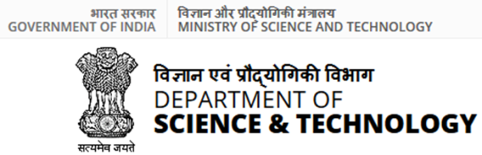



**Announcement**

**INDIA-EU Cooperation on research & innovation (R&I)**

**DST Announces Co-funding Partnership under the**

**EU Framework Programme on R&I ‘Horizon Europe’**

**Call 2024**

|  |
| --- |
| Collaboration in Science, Technology and Innovation (STI) plays an increasingly important role in the EU-India Strategic Partnership. In line with the EU-India Strategic Partnership: A Roadmap to 2025, and the Joint Science and Technology Steering Committee meeting on 12 February 2021, the Department of Science & Technology (DST), has identified calls for proposals in the [Work programmes 2023-2024](https://ec.europa.eu/info/funding-tenders/opportunities/portal/screen/how-to-participate/reference-documents;programCode=HORIZON) of the EU R&I Research and Innovation Programme ‘Horizon Europe’ (HE), which it considers of mutual interest and aiming at jointly tackling global challenges.  For this, DST has established a mechanism outlining the conditions upon which it will co-fund the successful Indian entity/ies and in which call topics have announced below following the Co-Funding Mechanism (hereafter CFM).  The CFM will apply to the call topics earmarked by DST in areas of **AI, Data and Robotics; electric energy storage solutions for grid support and charging infrastructure; zero emission vehicles; biofuels in line with Mission Innovation etc.** This notice explains in the different Sections hereunder how to prepare and submit a co-funded project.  In Section 1 the call topics earmarked by DST for co-funding are listed. The list indicates the exact Call IDs, the opening and closing date of the call, the type of action provided and the link to the full call text as published in the Horizon Europe Funding & Tenders Portal.  In Sections 2 and 3, the various modalities of participation that the Indian applicants have to comply with, including the Administrative and Financial Considerations (see Annex 1) is outlined.  All proposals have to be submitted to both the Horizon Europe [Funding & Tenders Portal](https://ec.europa.eu/info/funding-tenders/opportunities/portal/screen/programmes/horizon) and to DST’s [ePMS portal](https://onlinedst.gov.in/Login.aspx). The EU will only evaluate the proposal submitted to its portal. DST expects to receive the same copy in addition to all details on the budget, the Indian entity requires for its participation. Budget information to be provided in prescribed format and in Indian Rupees. In the absence of this, DST will disqualify the Indian participants from funding (see Section 4 hereunder).  At the end of the notice, information is provided on how to access and go about 'Horizon Europe' formalities, which also Indian applicants have to comply with (Annex 2) and on how to find partners (Annex 3).  For the complete call text click Horizon Europe Funding & Tenders Portal including the general conditions and modalities, and in particular the specific call conditions on the given call topic. Please read carefully the call text itself, which is the only legally binding text. |

CONTENT

Section 1: List of co-funded call topics 4

Section 2: Modalities of participation and funding for Indian applicants 5

1. Participation 5

1. 1. Participation of Indian Entity 5

1. 2. Participation of European Entity 6

1.3. Gender Balance 6

2. Eligibility 6

2.1. Indian Entities Eligible to Participate 7

2.2. European Entities Eligible to Participate 7

3. Funding 7

3.1 Funding by DST 7

3.2 Funding by EU 8

3.3 IPR: Ownership, Protection & User rights 8

4. Preparation of proposal 9

Section 3: DST TERMS AND CONDITIONS FOR INDIAN APPLICANT 11

Section 4: Process for submission of project proposal 11

1. Submission of proposal on Horizon Europe Funding & Tenders Portal 11

2. Submission of the proposal to DST including budget requested from DST 12

3. Formalities of submission to Horizon Europe Funding & Tenders Portal 13

Further Information 13

Annex 1: Templates for Administrative & Financial Considerations 14

Annex 2: How to Use and Access Horizon Europe Portal and Formalities 20

Annex 3: Finding partners 21

# Section 1: List of co-funded call topic

The CFM applies only to the call topics in Horizon Europe (HE) Work Programme 2023-2024 listed hereunder.

|  |  |  |  |  |  |
| --- | --- | --- | --- | --- | --- |
| **S. NO.** | **Title** | **Topic Identifier** | **Type of Action** | **Opening**  **Date** | **Closing Deadline** |
| **AI, Data and Robotics** | | | | | |
|  | **Explainable and Robust AI (AI Data and Robotics Partnership)** | [HORIZON-CL4-2024-HUMAN-03-02](https://ec.europa.eu/info/funding-tenders/opportunities/portal/screen/opportunities/topic-details/horizon-cl4-2024-human-03-02?status=31094501,31094502&frameworkProgramme=43108390&callIdentifier=HORIZON-CL4-2024-HUMAN-03&order=DESC&pageNumber=1&pageSize=50&sortBy=startDate) | RIA | Open | 18 September 2024 |
|  | Expected Outcome:   * Enhance the robustness, performance, and reliability of AI systems, including generative AI models, while being aware of operational limitations. * Improve the explainability, accountability, transparency, and autonomy of AI systems, including generative AI models, while considering the working conditions.   Scope:   * Develop trustworthy AI solutions that are robust, safe, reliable, and capable of providing meaningful explanations in real-world conditions. * Address concerns about fairness and ensure alignment with European regulations and ethical principles. * Focus on advancing AI algorithms and innovations to perform reliably under various circumstances and predict operational changes. * Emphasize multidisciplinary research involving expertise in sector-specific use cases, social sciences, and humanities. * Collaborate with open innovation challenges to address explainability and robustness issues. * Ensure adherence to ethical principles and fundamental rights in AI and robotics solutions. * Implement mechanisms to assess progress and share results within the European R&D community. * Encourage international cooperation, particularly with India.   Specific Topic Conditions:   * Activities should start at TRL 2-3 and achieve TRL 4-5 by the project's end.   For complete call text please visit Horizon Europe Portal: [Click Here](https://ec.europa.eu/info/funding-tenders/opportunities/portal/screen/opportunities/topic-details/horizon-cl4-2024-human-03-02?status=31094501,31094502&frameworkProgramme=43108390&callIdentifier=HORIZON-CL4-2024-HUMAN-03&order=DESC&pageNumber=1&pageSize=50&sortBy=startDate) | | | | |

To note that the type of collaborative actions, Research and Innovation (RIA) and Innovation Actions (IA) are established by Horizon Europe, and to be understood as follows[1]:

* **Research and innovation action (RIA)** that establishes new knowledge or explores a new or improved technology, product, process, service or solution. The EU funding covers up to 100% of the project costs.
* **Innovation action (IA)** that produces plans or designs for new or improved products, processes or services including prototyping, testing, demonstrating, piloting, large-scale product validation and market replication. The EU funding covers up to 70% of the project costs.

**Technology Readiness Levels**

Where the specific call conditions require a Technology Readiness Level (TRL), the following definitions apply, unless otherwise specified:

* TRL 1 — Basic principles observed
* TRL 2 — Technology concept formulated
* TRL 3 — Experimental proof of concept
* TRL 4 — Technology validated in a lab
* TRL 5 — Technology validated in a relevant environment (industrially relevant environment in the case of key enabling technologies)
* TRL 6 — Technology demonstrated in a relevant environment (industrially relevant environment in the case of key enabling technologies)
* TRL 7 — System prototype demonstration in an operational environment
* TRL 8 — System complete and qualified
* TRL 9 — Actual system proven in an operational environment (competitive manufacturing in the case of key enabling technologies, or in space)

# Section 2: Modalities of participation and funding for Indian applicants

# 1. Participation

## 1. 1. Participation of Indian Entity

**Participation entity in Horizon Europe projects**

* Eligibility of Indian entities is defined by DST.
* Since the Indian entity is not receiving funding from the EU under Horizon Europe, it is not required to sign the EU Grant Agreement. It will participate as “**Associated Partner**” and mentioned as such in Article 9.1 of the EC grant Agreement.
* This means that the Indian entity is expected to contribute to the smooth implementation of the project as specified in the consortium agreement.

**Formality for Participation**

* If you want to participate in a Horizon Europe project proposal, your organisation needs to be registered in the Participant Register of the Funding & Tenders Portal and have a 9-digit [Participant Identification Code (PIC)](https://eufunds.me/how-to-get-a-pic-number-on-the-funding-tenders-portal/) number (see registration procedure in Annex 2). For any help, contact EU (see section - future information).

**Number of Indian entities per projects**

* There is no legal requirement on number of Indian entities in a given project eligibility condition. Any legal entity/organization (public or private research institute/university) established in India with expertise in relevant and distinct disciplines. No limit on number of Indian participants but each partner should be necessary for the execution of the project and comply with the eligibility conditions (see section 2).
* The call is open to all career groups (i.e. early, intermediate and senior); however, it is expected that each investigator shall have adequate service tenure to accommodate key research, coordination, outreach, post completion handholding and maintenance (if any) responsibilities. Early career investigators are encouraged to participate.
* Each participating legal entity/organisation (public or private research institute/university) should be represented by at least two investigators (see section 2).
* The number of Indian project partners should be optimum and correspond to the objectives of the project. The proposal should clearly demonstrate each partner’s essentiality, complementarities, and added- value in jointly addressing the topic.
* In case there is more than one Indian legal entity/organization participating in a given project, it is advised that the Indian participants appoint among them a ‘Lead Scientific Coordinator-INDIA', who can represent the Indian participants in the consortium vis-à-vis DST. To ensure continuity in the project, at least two investigators (one Project Investigator and at least one Co-Investigator) must represent each participating legal entity/organization.

## 1. 2. Participation of European Entity

**Number of European entities per projects**

* Collaborative research & innovation projects carried out by consortia of organisations working together on specific research & innovation areas. A consortium must include at **least 3 partner organisations from 3 different Member States or associated countries**. At least **one of the 3 partners must be from Member States**.
* **European Union member states (EU27)**: *Austria, Belgium, Bulgaria, Croatia, Republic of Cyprus, Czech, Republic, Denmark, Estonia, Finland, France, Germany, Greece, Hungary, Ireland, Italy, Latvia, Lithuania, Luxembourg, Malta, Netherlands, Poland, Portugal, Romania, Slovakia, Slovenia, Spain and Sweden*.
* **Countries Associated with Horizon Europe[2]**: *Agreements in place: Albania, Armenia, Bosnia and Herzegovina, Faroe Islands, Georgia, Iceland, Israel, Kosovo, Moldova, Montenegro, New Zealand (associated to HE Pillar II 'Global Challenges), North Macedonia, Norway, Serbia, Tunisia, Türkiye, Ukraine and United Kingdom (on 1 January 2024, the UK becomes an associated country, except EIC)*
* In addition to these three partners, any legal entity from anywhere in the world can be included in the consortium. Please consult the Horizon Europe programme guide[3].

## 1.3. Gender Balance

Applicants are encouraged to promote equal opportunities in the implementation of the action by ensuring a balanced participation of women and men at all levels of the research and innovation teams and in the management structures.

# 2. Eligibility

The participating entities/organisations from India have to be a legal entity as per Indian law (Indian applicants) and the European entities as per the [Horizon Europe rules of participation](https://ec.europa.eu/info/funding-tenders/opportunities/docs/2021-2027/horizon/wp-call/2021-2022/wp-13-general-annexes_horizon-2021-2022_en.pdf).

## 2.1. Indian Entities Eligible to Participate

* Central Government / State Government supported or recognized (Public or Private) academic and/or research institution(s);
* National / State funded R&D Labs;
* Government of India / State Government recognized Organizations, having research and innovation as one of the imperative mandates; R&D centres recognised as Scientific Industrial Research Organization (SIRO) by DSIR;
* The scientific R&D performing Indian industry may participate voluntarily in this call with participating Indian industry investing its own resources or come in collaboration with research/academic organization, but by investing their own resources.

**Academic/Research Partners:**

* Public and/or private universities and research organisations must have a well-established research support system for research. Submission of proof of establishment under Indian statue; recognition documents and registration at Government of India's [Public Finance Management System (PFMS)](https://pfms.nic)[4]is mandatory.

All Indian applicants should abide /comply with the terms & conditions of the grant of DST.

## 2.2. European Entities Eligible to Participate

* Any legal entity is eligible to participate, provided that the conditions laid down in the Horizon Europe Regulation have been met, along with any other conditions laid down in the specific call topic[5].

# 3. Funding

## 3.1 Funding by DST

DST will fund the Indian partners/entities in a successful project, as per requirement of the project, for the project duration up to 3 years. The project duration should match-up with the durations of all partner countries.

Budget should be commensurate with the essentiality of participation, workload, objectives of the project and cost of participation.

**3.1.1 Eligibility for Funding**

Budgeted costs of the project to legal entities subject to obligatory fulfilment of eligibility criteria, DST will support:

**Grant-in-aid: 100%** of the approved budget costs to the following two categories of organizations such as Government of India supported or recognised public or private academic institutions or research organisation / labs (maximum to **₹1.5 crore** per project, regardless of number of Indian participating entities). The eligible budget cost to be supported by DST includes: Capital expenditure (equipment's & fabrication costs), Manpower, Consumables, Travel (local and international travel), Testing & Standardisation Costs, Contingency, Overheads (as per DST norms), etc. excluding Civil Construction costs, Prosecution / litigation costs, Salary of investigators). The equipment cost can include partial cost of first application / demonstration, which has to be borne by respective organisation. However, testing costs as per agreed protocol of the first application / deployment are admissible under testing and standardization costs.

**3.1.2 Non-Admissible Cost from DST**

1. Prosecution/litigation costs;
2. Salary of investigators;
3. Capital expenditure for the purchase of assets such as office furniture, motor vehicles, Office equipment viz. desktops, laptops, tablets, cell phones, scanners, printers, photocopy machines, and renovation or extension of facilities such as buildings and laboratories;
4. Capital expenditure toward technology(ies), demonstration plants and associated field equipment(s), hardware, software etc. for test and analysis from consortium partner(s) from abroad;
5. Expenditure toward rental and utilities;
6. International travel to countries other than the one participating within the consortia in a particular call topic of Horizon Europe;
7. Mere attendance at conferences/ symposiums/ congresses

## 3.2 Funding by EU

Funding of European partners is as per Horizon Europe rules of participation and in function of type of action [RIA & IA][6].

## 3.3 IPR: Ownership, Protection & User rights

* IPR legislation and other rules are often crucial for participants in research projects, as they may have a deep influence on the way in which the knowledge can be shared during a project development, and in which project results can be commercially used.
* The participants shall jointly develop a Consortium Agreement (CA). The CA is a specific agreement to be concluded between the participants in joint research, defining, among other things, ownership, protection, user rights for research and development purposes, exploitation and dissemination, including arrangements for joint publication, the rights and obligations of visiting researchers and dispute settlement procedures. The CA shall also address foreground and background information, licensing and deliverables.
* The IPR issues for all the proposals need to satisfy the S&T agreement between EU and India[7].

# 4. Preparation of proposal

The Indian and European participants must formulate a joint proposal, according to the requirements and [templates](https://ec.europa.eu/info/funding-tenders/opportunities/docs/2021-2027/horizon/temp-form/af/af_he-ria-ia_en.pdf) provided by respectively Horizon Europe Funding & Tenders Portal format[8] and DST's administrative and financial requirements (see annex 1). Complying with the formats and templates of Horizon Europe and DST for the Indian partners is mandatory. Indian entities should participate as an **Associated Partners.**

The Horizon Europe proposal consists of two main parts:

* **Part A:** the **Administrative Forms** containing general information on the project (title, abstract, and keywords), the consortium (basic administrative data, contact persons, declarations) and the budget overview.
* **Part B**: the **Technical Annex** containing the detailed description of the planned research and innovation project. The structure is based on the evaluation criteria (cite them here) as provided in the proposal template for a RIA/IA.

**How to Add Associated Partners to a Proposal on the Funding & Tenders Portal**

Entities based in India can participate to Horizon Europe projects by applying under the participant role of “**Associated Partners” (AP)**.

This is a step-by-step guide on (to be completed via European proposal coordinator):

* how to add an AP to a proposal on the Portal
* how to include the budget of an AP on the Portal
* 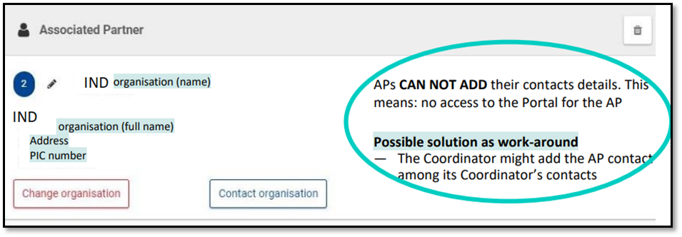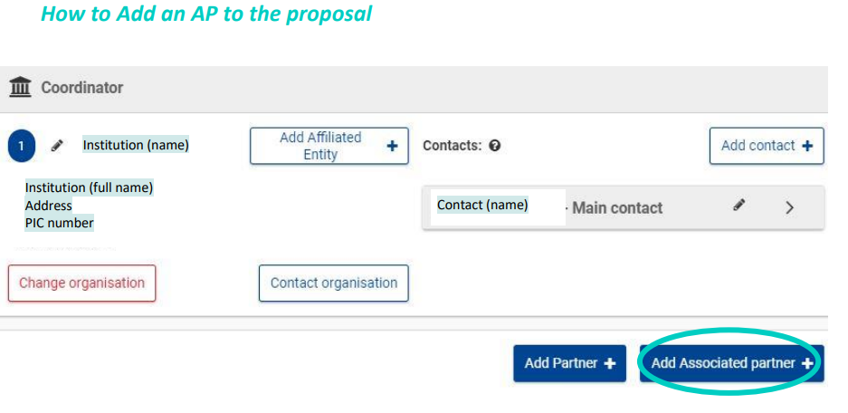how to deal with the budget table for Lump Sum projects

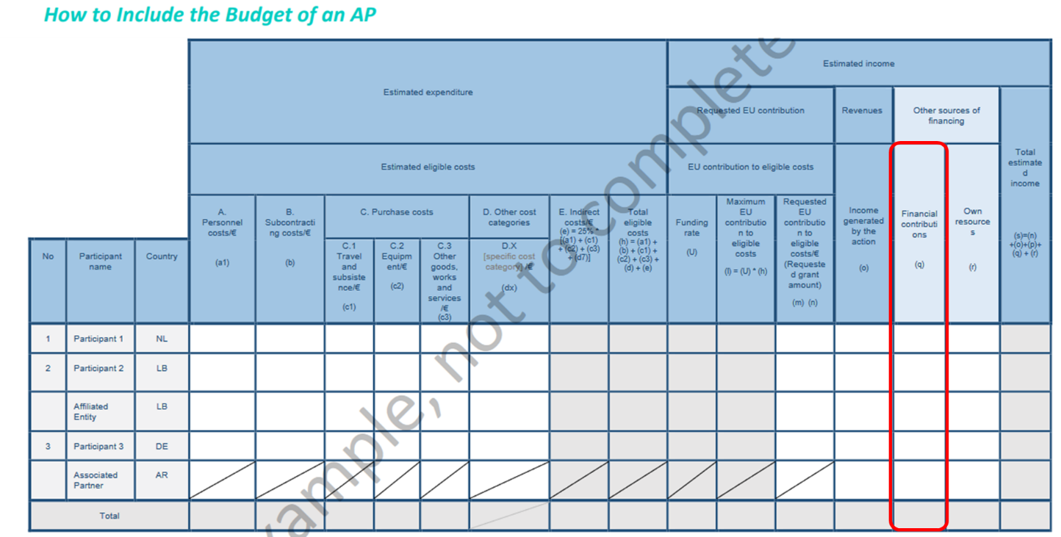

|  |
| --- |
| “**Financial Contribution**”. Insert here the amount that the Indian entity participating as an AP intends to request from DST.  In general, this budget category is used for any financial contribution expected to be received/ already received from other sources for being used specifically for the same action as the one submitted for funding under Horizon Europe (e.g. funding from DST). |

Tasks attributed to the Associated Partner must be described in the technical description (Part B) of the project. If you wish, you can also include in this section the estimated budget of the entity (not mandatory).

**Indian participants prepare budget (in Rupees) according to DST requirements and templates**

* Indian participants **MUST** submit detailed financial plan in **Indian Rupees (₹)** for duration of the project to DST only.
* The detailed Indian financial plan for each Indian participant in the project must be specified according to format provided by DST in Annex 1*.*

**DST's budget calculation for Indian participants**

Maximum of One crores fifty lakhs Rupees (₹1,50,00,000/-) per project will be made available by DST to the successful Indian participant(s) in a collaborative project with European partners under 'Horizon Europe'. DST will decide final number of funded projects.

Indian participant must ensure that each Indian participant follows budget format proposed by the DST.

**Direct Costs:**

1. **Manpower cost**: as per the requirements of the project (emoluments will be as per prevailing Gov. of India norms);
2. **Mobility of investigator(s) & project staff(s):** for visit(s) and work related to the project to be undertaken by Indian investigator(s) & project staff(s) **in Europe,** the cost of travel and man-days of stay in European countries (i.e. round-trip international travel by economy class, admissible insurances, local transport, boarding and lodging) must be justifiably budgeted by respective Indian organisation for each year, at 8.1, 8.2 and 8.3 (as applicable) of Annex 1. Institution hosting the collaborating investigator(s) & project staff(s) of other consortium participants, shall provide research facility and research resources to accomplish defined objectives and if required, this can be reflected in each participant budget adequately.
3. **Overhead/Indirect Cost:** overhead expenses payable to legal entity/organization for Indian partners, up to 10% of the total project cost for educational institutions and up to 8% for laboratories and institutions under central Government Departments/Agencies as per prevailing Gov. of India norms.

|  |
| --- |
| ***||to be noted ||***   * *Indian entity(ies) will submit detailed financial plan in Indian Rupees only to DST* * *The budget that DST provides to Indian participants does not cover expenses incurred by the European and other countries’ applicants in the consortium.* * *Indian entity(ies) will not sign EC’s Grant Agreement but considered as ‘Associated Partners’.* * *Each side will bear their own cost of implementation of project including travel, premium for medical insurance, accommodation, boarding/loading, visa fee, food, per diem.* |

# Section 3: DST TERMS AND CONDITIONS FOR INDIAN APPLICANT

* Indian applicants should follow the DST’s Terms and Conditions.
* The final technology developed under the project will have to meet the relevant India / international standards, if already available. Otherwise, all partners will pursue respective organizations at their respective countries for bringing such standards.
* Indian applicants will have to follow the provisions of General Financial Rules (GFR)[9]2017 and / or any other rules as decided by DST from time-to-time.

# Section 4: Process for submission of project proposal

All proposals with Indian applicants should be submitted to both Horizon Europe Funder & Tenders portal and to DST’s [ePMS online portal](https://onlinedst.gov.in/Login.aspx).

## 1. Submission of proposal on Horizon Europe Funding & Tenders Portal

A joint proposals must be submitted electronically using the electronic submission system of the Funding & Tenders Portal[10]. This task will be done by designated European Project Coordinator. Please ensure he/she gets all the required information from Indian participant(s) on time. In preparation thereof, Indian applicants should have their Personal Identification Code (PIC). See Annex 2 hereunder. For more information, see [Proposal Submission Service User Manual](https://ec.europa.eu/research/participants/data/support/sep_usermanual.pdf)[11].

## 2. Submission of the proposal to DST including budget requested from DST

The Indian participant(s) must submit the **complete proposal,** (Part A + Part B) and **same** as submitted on the Horizon Europe Funding & Tenders Portal), as one single consolidated PDF file (Part A + Part B + DST’s administrative and financial form) at e-PMS (www.onlinedst.gov.in) along with other requisite documents. **This online submission to DST ePMS portal should be completed within 7 working days of respective calls closure dates mentioned above.** **PROPOSAL WILL NOT BE ACCEPTED BY POST (HARD COPY) OR EMAIL.**

Please note that in absence of timely submission or any discrepancy found in the proposal submitted at Horizon Europe Funding & Tenders Portal and to DST will result in disqualification from consideration by DST for funding.

**Instructions for uploading proposal to DST on e-PMS**

1. Log on [onlinedst.gov.in](http://upsssc.gov.in/AllNotifications.aspx) to access the home page of the “DST e-PMS Portal” and register. After registration, log in and submit the joint project proposal in prescribed Format.
2. Before filling up the form Indian applicants are advised to carefully go through the Relevant Advertisement published at the DST Website (www.dst.gov.in) and also available under Proposal Formats in the e-PMS Portal after logging in the portal site.
3. To save time and avoid data loss, please download the appropriate proposal format and fill all the information required as per the format as a Word and PDF file and then keep it ready for upload during submission of mandatory documents.
4. Click on “Submit proposals” link which would take to a page seeking multiple information starting with – General information, Principal investigator etc.:
5. After filling all above particulars, there is provision for preview your details before final submission of application form on clicking on “Preview” button. Preview page will display all facts/particulars that have mentioned on entry time. If the applicant are sure with filled details then click on “Submit” button to finally push data into server.

Applicants are advised to carefully fill in and verify the details required for the online application themselves, as no change will be possible/ entertained after clicking the FINAL SUBMIT BUTTON.

**List of documents required for online submission DST e-PMS**

The followings documents shall be prepared by Indian PI and uploaded on the DST Portal- [www.onlinedst.gov.in](http://www.onlinedst.gov.in) . The requisite format is listed below.

1. Biodata (PDF only max size 800 KB)
2. Certificate from Investigator(s) (PDF only max size 800 KB) (Annexure A)
3. Endorsement from the Head of Organisation (on letter head) (PDF only max size 800 KB) (Annexure B)
4. Conflict of Interest (PDF only max Size 800 KB) (Annexure C)
5. Complete Proposal (1 pdf file: Part A + Part B + administrative and financial form (same as submitted on the Horizon Europe Funding & Tenders Portal) as indicated in online portal (PDF max size 5 MB) and [complete Project Proposal in Word only max size 5 MB]

## 3. Formalities of submission to Horizon Europe Funding & Tenders Portal

* Before submitting a proposal, any applicant (from Europe or India) needs to be registered by the European Commission and obtain for this purpose a Personal Identification Code also called PIC: see registration procedure in Annex 2).
* Online guidance is also provided on how to fill in the administrative forms (Part A).
* Proposal templates for the technical annex can be downloaded from the system. The technical annex and any additional annexes have to be uploaded as PDF documents.
* The templates to comply with for DST requirement are available on DSTs website only.

**For more details see:** <https://ec.europa.eu/info/funding-tenders/opportunities/portal/screen/how-to-participate/how-to-participate/1>

# Further Information

**DST contacts:**

**Dr. Praveen Kumar S**, Head

International Cooperation Division,

Department of Science and Technology

New Mehrauli Road, New Delhi -110016

[praveen@nic.in](mailto:praveen@nic.in)

**Dr. Mahak Garg**, Scientist C

International Cooperation Division,

Department of Science and Technology

New Mehrauli Road, New Delhi - 110016

[mahak.garg@gov.in](mailto:mahak.garg@gov.in)

**EU Contacts:**

* [DELEGATION-INDIA-RI@eeas.europa.eu](mailto:DELEGATION-INDIA-RI@eeas.europa.eu)

# Annex 1: Templates for Administrative & Financial Considerations

**Maximum of One crores fifty lakhs Rupees (₹1,50,00,000/-) per project**

**Format for Budget Details**

**Name of the Investigator:**

**Name of the Institution:**

**Type of Organisation:**

|  |  |  |  |  |  |
| --- | --- | --- | --- | --- | --- |
| **S. No** | **Item Head** | **1st Year** | **2nd Year** | **3rd Year** | **Total (Rs.)** |
| **A** | **Non-recurring (Capital Items)** | | | | |
|  | Minor Equipment; Fabrication costs; Prototype development; Demonstration costs (if any) |  |  |  |  |
| **B** | **Recurring Items (General)\*** | | | | |
|  | Manpower |  |  |  |  |
|  | Consumables |  |  |  |  |
|  | Travel (Domestic) |  |  |  |  |
|  | Travel (International) |  |  |  |  |
|  | Contingency (as per DST norms) |  |  |  |  |
|  | Overhead (as per DST norms) |  |  |  |  |
|  | *Subtotal (General)* |  |  |  |  |
| **C** | **Total cost of the project (A+B)** |  |  |  |  |

*The cost incurred towards field trials/testing may be added in appropriate budget heads.

Justification for costs projected in each budget head is required.

To be noted: the budget could be re-assessed based on suggestions / recommendations from the expert committee.

**Details of Itemized Budget**

*(* To be given institution/ research group-wise in case of consortium projects)*

**A. Non-recurring (Capital Items)**

**A.1 Minor Equipment\***

**Budget for Minor Equipment (**To be borne by DST**)**

|  |  |  |  |  |
| --- | --- | --- | --- | --- |
| **Description of Minor Equipment** | **Unit Landed Price (CIF+ Custom Duty/ Taxes + others charges etc.)* ( Rs.in lakh )** | **Nos.**  **of**  **Equipment** | **Total Cost**  **(Rs. in lakh)** | **Justification in context of proposed work.** |
|  |  |  |  |  |
|  |  |  |  |  |
|  |  |  |  |  |
|  |  | **Gross total =** | | |

*\*Page/sheet indicating the total landed cost in Indian rupees (****Ensure to mention Currency Exchange rate considered in case of imported equipment,*** *freight, taxes, spares, special installation, etc.) Please project the actual cost taking into account reliable cost estimates as no cost revision would be admissible*

**A.2 Fabricated system / Prototype Development: Tailor made models/ experimental set up (if any)**

**i) Budget for Fabricated system/Tailor made items**

|  |  |  |  |  |
| --- | --- | --- | --- | --- |
| **Description of fabricated system** | **Unit Landed Price (CIF+ Custom Duty+ others charges)* (Rs in lakh)** | **Nos.**  **of**  **Equipment** | **Total Rupees**  **(Rs. in lakh)** | **Justification in context of proposed work** |
|  |  |  |  |  |
|  |  |  |  |  |
|  |  |  |  |  |
|  | Gross total | | | | |

*\*Page/sheet indicating the total landed cost in Indian rupees (Ensure* ***to mention Currency Exchange rate considered in case of imported equipment,*** *freight, taxes, spares, special installation, etc.) Please project the actual cost taking into account reliable cost estimates as no cost revision would be admissible*

**A.3 Demonstration Models**

**i) Budget for Demonstration Models items**

|  |  |  |  |  |
| --- | --- | --- | --- | --- |
| **Description** | **Unit Landed Price (CIF+ Custom Duty+ others charges)\***  **(Rs in lakh)** | **Nos.**  **of**  **Equipment** | **Total Rupees**  **(Rs. in lakh)** | **Justification in context of proposed work** |
|  |  |  |  |  |
|  |  |  |  |  |
|  |  |  |  |  |
|  | Gross total | | | | |

*\*Page/sheet indicating the total landed cost in Indian rupees (Ensure* ***to mention Currency Exchange rate considered in case of imported equipment,*** *freight, taxes, spares, special installation, etc.) Please project the actual cost taking into account reliable cost estimates as no cost revision would be admissible*

**B. Recurring Items (General)**

**B.1 Manpower**

|  |  |  |  |
| --- | --- | --- | --- |
| **Designation\*** | **Educational Qualification** | **Experience**  **in years, if applicable** | **Justification** |
|  |  |  |  |
|  |  |  |  |
|  |  |  |  |

**\*Refer guidelines at DST website:**

<https://dst.gov.in/sites/default/files/OM%20Fellowship%20Revision-2019.pdf>

<https://dst.gov.in/sites/default/files/S%26T-Manpower-Norms-10July2020.pdf>

**(Emoluments shall be provided as per Guidelines)**

**Manpower Budget**

**JRF /SRF/ Research Associates/ Project Assistants Details (applicable for the given category)**

|  |  |  |  |  |  |  |  |
| --- | --- | --- | --- | --- | --- | --- | --- |
| **Designation** | **Total Emoluments (in Rupees)** | | | | | **No. of persons** | **(Inclusive of all Allowances)\***  **Total Amount**  **(Rs.)** |
| 1st Year | 2nd Year | 3rd Year |  | Total (1st +2nd+3rdYear |
|  |  |  |  |  |  |  |  |
|  |  |  |  |  |  |  |  |
|  |  |  |  |  |  |  |  |
|  |  | Gross amount required for manpower budget head = | | | | |  |

*\*Please mention category/ class of city for admissible HRA along with %.*

**B.2 Consumables**

**Budget for Consumable Materials (***To be borne by DST****)***

|  |  |  |  |  |
| --- | --- | --- | --- | --- |
| **Items** | **Unit Price** | **Qty. Needed** | **Amount**  **(Rs. in lakh)** | **Justification** |
|  |  |  |  |  |
|  |  |  |  |  |
| Gross total =Rs. lakh | | | | |

**B.3 Contingencies**

**Budget for Contingencies (***To be borne by DST***)**

|  |  |  |
| --- | --- | --- |
| **Items**  *(unforeseen expenses, patents, report preparations etc.)* | **Amount**  **(Rs. in lakh)** | **Justification** |
|  |  |  |
| **Total** |  |  |

**B.4 Travel Domestic \***

**Budget for Domestic Travel (**To be borne by DST**)**

|  |  |  |
| --- | --- | --- |
| **Items**  **(to attend)** | **Total Amount** | **Detailed Justification (In case of extensive field visits needed in project indicating breakup of cost w.r.t. to journeys, mode and class of transport needed)** |
|  |  |  |
| Review meetings |  |  |
| Sample collection / field trials |  |  |
| Total |  | |

**B.5 Travel International \***

**Budget for International Travel (**To be borne by DST**)**

|  |  |  |
| --- | --- | --- |
| **Items**  **(to attend)** | **Total Amount** | **Detailed Justification** |
|  |  |  |
|  |  |  |
| Total |  | |

**\* Project Investigator needs to take prior permission from DST for his/her international visit related to project work**

**B.6 Other Costs**, **if applicable**

**Budget for Other Costs (**To be borne by DST**)**

|  |  |  |
| --- | --- | --- |
| **Item** | **Total**  **(Rs. in lakh)** | **Detailed Justification (derived cost calculation and relevant Quotation at Annexure- / page no*)** |
| Outsource work |  |  |
| Testing / Standardisation |  |  |
| Other items, if any |  |  |
| **Gross total =** | Rs. | |

**Collaborator budget / Contribution**

Submit similar above detail breakup for each collaborator, if any

**Organization details:**

* 1. Designation of the financial authority in organization:
  2. Whether organization registered with Govt. of India Public Financial Management System (PFMS) Yes/ No

*(see website: https://pfms.nic.in/NewDefaultHome.aspx)

* 1. If not, please get it registered as soon as possible at PFMS website under Research and Development Scheme code– 3237 which is mandatory. If yes, inform Agency code registered at PFMS

# Annex 2: How to Use and Access Horizon Europe Portal and Formalities

**How to Participate:**

By selecting the “[How to Participate](https://ec.europa.eu/info/funding-tenders/opportunities/portal/screen/how-to-participate/how-to-participate/1)” tab on the Horizon Europe Funding & Tenders Portal “Home” page, researchers and innovators will be directed to a page that provides easy access and instructions for using key parts of the portal (see screen shot below):

* Create an Account
* Register an Organization
* Find Partners
* Find a Call for Proposals
* Submit a Proposal

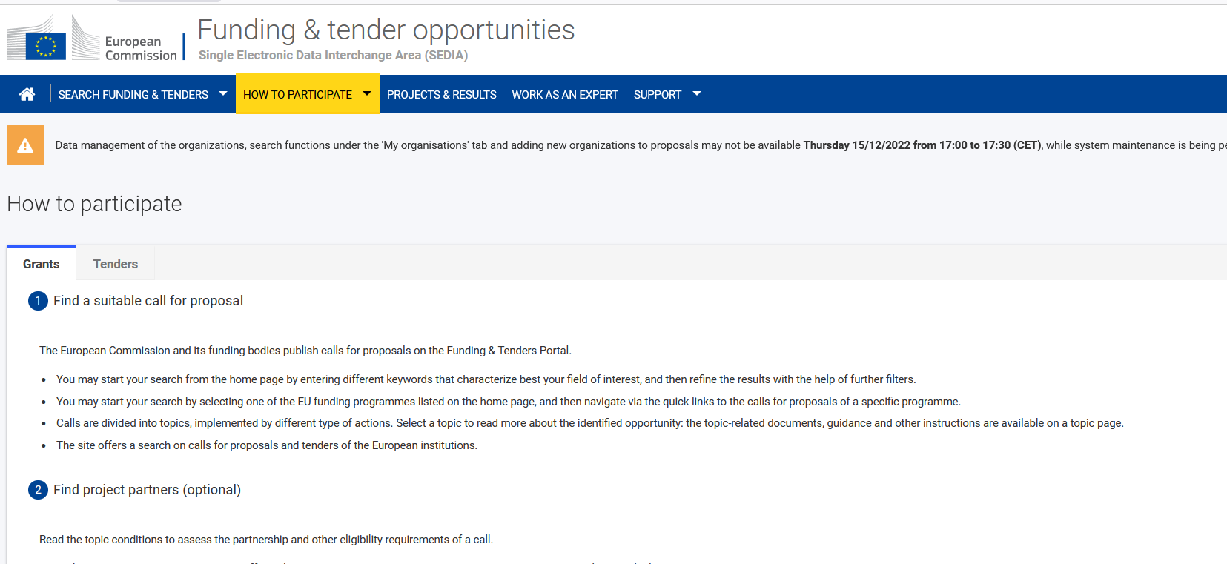

# Annex 3: Finding partners

The starting point is to consider partners with whom you already have direct or indirect connections. As participation in a Horizon Europe call requires an interdisciplinary and/or inter-sectoral approach for a challenge to be addressed appropriately, it may become necessary to look for partners outside the usual circle of contacts.

Hereunder you will find a list of European services that assist in finding the right partners:

|  |  |
| --- | --- |
| **Partner search tools** | |
| Partner Search for organisation profiles on the EC platform | Find partners for your project ideas among the organisations registered in the [Funding & Tenders Portal](https://ec.europa.eu/info/funding-tenders/opportunities/portal/screen/how-to-participate/partner-search) of the European Commission. |
| Find partners with the help of Enterprise Europe Network | The [Enterprise Europe Network](https://www.swisseen.ch/en/) online database contains over 2,500 technology profiles (offers and requests) from companies and R&D organisations from over 60 countries in Europe and beyond. |
| Guide to an adequate partner search | Horizon Europe: [Guide to an adequate partner search](https://horizoneuropencpportal.eu/sites/default/files/2022-05/guide-for-ps-tool.pdf) |
| [Expressed Interest](https://ec.europa.eu/info/funding-tenders/opportunities/portal/screen/how-to-participate/partner-search) | Horizon Europe Funding & Tenders Portal: search by call topics where organisations have participated or expressed interest in participating in the future. |
| [euMatch 2.0](https://mm.fitforhealth.eu/) | Partner Search and Matchmaking platform to find partners and project initiatives to participate in H2020 supported health related projects. |
| [NCP Network](https://horizoneuropencpportal.eu/sites/default/files/2022-05/guide-for-ps-tool.pdf) | National Contact Points for Horizon Europe |

**Annexure A**

**Certificate from the Investigator**

**Project Title:**

1. I/ We agree to abide by the terms and conditions of the DST/DBT research grant.

2. I/ We did not submit the project proposal under consideration elsewhere for financial support.

3. I/ We have explored and ensured that equipment and basic facilities (enumerated at Point 16) will actually be available as and when required for the purpose of the projects. I/We shall not request financial support under this project, for procurement of these items.

4. I/ We undertake that spare time on permanent equipment made available to other users.

5. I/We have enclosed the following documents uploaded online portal.

i) Biodata of all Lead PIs.

ii) Certificate from Investigator(s)

iii) Endorsement from the Head of Institution (on letter head)

iv) Conflict of Interest

v) Complete Proposal (1pdf file and 1Doc file)

Name of PI and Signature

Date:

Place:

**Annexure B**

**Endorsement from the Head of Institution**

(To be given on letter head)

**Project Title:**

1. Certified that the Institute welcomes participation of Dr_____________________________ as the Principal Investigator and Dr____________________________ as the Principal Co-Investigator for the project and that in the unforeseen event of discontinuance by the Principal Investigator, the Principal Co-Investigator will assume the responsibility of the fruitful completion of the project (with due information to DST/DBT).

2. Certified that the equipment and other basic facilities as enumerated at Point 16 and such other administrative facilities as per terms and conditions of the grant, will be extended to the investigator(s) throughout the duration of the project.

3. Institute assumes to undertake the financial and other management responsibilities of the project.

Name and Signature of Head of Institution

Date:

Place:

**Annexure C**

**DEPARTMENT OF SCIENCE AND TECHNOLOGY POLICY ON CONFLICT OF INTEREST FOR REVIEWER & COMMITTEE MEMBER or APPLICANT or DST/DBT OFFICER ASSOCIATED/ DEALING WITH THE SCHEME/ PROGRAM OF DST/DBT**

Issues of Conflicts of Interest and ethics in scientific research and research management have assumed greater prominence, given the larger share of Government funding in the country's R & D scenario. The following policy pertaining to general aspects of Conflicts of Interest and code of ethics, are objective measures that is intended to protect the integrity of the decision making processes and minimize biasness. The policy aims to sustain transparency, increase accountability in funding mechanisms and provide assurance to the general public that processes followed in award of grants are fair and nondiscriminatory. The Policy aims to avoid all forms of bias by following a system that is fair, transparent and free from all influence/ unprejudiced dealings, prior to, during and subsequent to the currency of the programme to be entered into with a view to enable public to abstain from bribing or any corrupt practice in order to secure the award by providing assurance to them that their competitors will also refrain from bribing and other corrupt practice and the decision makers will commit to prevent corruption, in any form, by their officials by following transparent procedures. This will also ensure a global acceptance of the decision making process adopted by DST/DBT.

**Definition of Conflict of Interest:**

Conflict of Interest means "any interest which could significantly prejudice an individual's objectivity in the decision making process, thereby creating an unfair competitive advantage for the individual or to the organization which he/she represents". The Conflict of Interest also encompasses situations where an individual, in contravention to the accepted norms and ethics, could exploit his/her obligatory duties for personal benefits.

**1. Coverage of the Policy:**

a) The provisions of the policy shall be followed by persons applying for and receiving funding from DST/DBT, Reviewers of the proposal and Members of Expert Committees and Programme Advisory Committees. The provisions of the policy will also be applicable on all individuals including Officers of DST/DBT connected directly or indirectly or through intermediaries and Committees involved in evaluation of proposals and subsequent decision making process.

b) This policy aims to minimize aspects that may constitute actual Conflict of Interests, apparent Conflict of Interests and potential Conflict of Interests in the funding mechanisms that are presently being operated by DST/DBT. The policy also aims to cover, although not limited to, Conflict of interests that are Financial (gains from the outcomes of the proposal or award), Personal (association of relative / Family members) and Institutional (Colleagues, Collaborators, Employer, persons associated in a professional career of an individual such as Ph.D. supervisor etc.)

2. **Specifications as to what constitutes Conflict of Interest**.

Any of the following specifications (non-exhaustive list) imply Conflict of Interest if,

1. Due to any reason by which the Reviewer/Committee Member cannot deliver fair and objective assessment of the proposal.
2. The applicant is a directly relative# or family member (including but not limited to spouse, child, sibling, parent) or personal friend of the individual involved in the decision making process or alternatively, if any relative of an Officer directly involved in any decision making process / has influenced interest/ stake in the applicant’s form etc.
3. The applicant for the grant/award is an employee or employer of an individual involved in the process as a Reviewer or Committee Member; or if the applicant to the grant/award has had an employer-employee relationship in the past three years with that individual.
4. The applicant to the grant/award belongs to the same Department as that of the Reviewer/Committee Member.
5. The Reviewer/Committee Member is a Head of an Organization from where the applicant is employed.
6. The Reviewer /Committee Member is or was, associated in the professional career of the applicant (such as Ph.D. supervisor, Mentor, present Collaborator etc.)
7. The Reviewer/Committee Member is involved in the preparation of the research proposal submitted by the applicant.
8. The applicant has joint research publications with the Reviewer/Committee Member in the last three years.
9. The applicant/Reviewer/Committee Member, in contravention to the accepted norms and ethics followed in scientific research has a direct/indirect financial interest in the outcomes of the proposal.
10. The Reviewer/Committee Member stands to gain personally should the submitted proposal be accepted or rejected.

# The Term “Relative” for this purpose would be referred in section 6 of Companies Act, 1956.

**3. Regulation:**

The DST shall strive to avoid conflict of interest in its funding mechanisms to the maximum extent possible. Self-regulatory mode is however recommended for stake holders involved in scientific research and research management, on issues pertaining to Conflict of Interest and scientific ethics. Any disclosure pertaining to the same must be made voluntarily by the applicant/Reviewer/Committee Member.

**4. Confidentiality:**

The Reviewers and the Members of the Committee shall safeguard the confidentiality of all discussions and decisions taken during the process and shall refrain from discussing the same with any applicant or a third party, unless the Committee recommends otherwise and records for doing so.

**5. Code of Conduct**

**5.1 To be followed by Reviewers/Committee Members:**

(a) All reviewers shall submit a conflict of interest statement, declaring the presence or absence of any form of conflict of interest.

(b) The reviewers shall refrain from evaluating the proposals if the conflict of interest is established or if it is apparent.

(c) All discussions and decisions pertaining to conflict of interest shall be recorded in the minutes of the meeting.

(d) The Chairman of the Committee shall decide on all aspects pertaining to conflict of interests.

(e) The Chairman of the Committee shall request that all members disclose if they have any conflict of interest in the items of the agenda scheduled for discussion.

(f) The Committee Members shall refrain from participating in the decision making process and leave the room with respect to the specific item where the conflict of interest is established or is apparent.

(g) If the Chairman himself/herself has conflict of interest, the Committee may choose a Chairman from among the remaining members, and the decision shall be made in consultation with Member Secretary of the Committee.

(h) It is expected that a Committee member including the Chair-person will not seek funding from a Committee in which he/she is a member. If any member applies for grant, such proposals will be evaluated separately outside the Committee in which he/she is a member.

**5.2**  **To be followed by the Applicant to the Grant/Award**:

(a) The applicant must refrain from suggesting referees with potential Conflict of Interest that may arise due to the factors mentioned in the specifications described above in Point No. 2.

(b) The applicant may mention the names of individuals to whom the submitted proposal should not be sent for refereeing, clearly indicating the reasons for the same.

**5.3 To be followed by the Officers dealing with Programs in DST/DBT**:

While it is mandatory for the program officers to maintain confidentiality as detailed in point no. 6 above, they should declare, in advance, if they are dealing with grant applications of a relative or family member (including but not limited to spouse, child, sibling, parent) or thesis/ post-doctoral mentor or stands to benefit financially if the applicant proposal is funded. In such cases, DST/DBT will allot the grant applications to the other program officer.

**6. Sanction for violation**

**6.1 For a) Reviewers / Committee Members and b) Applicant**

Any breach of the code of conduct will invite action as decided by the Committee.

**6.2 For Officers dealing with Program in DST/DBT**

Any breach of the code of conduct will invite action under present provision of CCS (conduct Rules), 1964.

**7. Final Appellate authority:**

Secretary, DST/DBT shall be the appellate authority in issues pertaining to conflict of interest and issues concerning the decision making process. The decision of Secretary, DST/DBT in these issues shall be final and binding.

**8. Declaration**

**I have read the above “Policy on Conflict of Interest” of the DST/DBT applicable to the Reviewer/ Committee Member/ Applicant/ DST/DBT Scheme or Program Officer # and agree to abide by provisions thereof**.

I hereby declare that I have no conflict of interest of any form pertaining to the proposed grant *

I hereby declare that I have conflict of interest of any form pertaining to the proposed grant *

*\* & # (Tick whichever is applicable)*

**Name of the Reviewer/ Committee Member or Applicant or DST/DBT Officer**

**(*Strike out whichever is not applicable*)**

**(Signature with date)**

1. <https://rea.ec.europa.eu/horizon-europe-how-apply_en>
2. <https://ec.europa.eu/info/funding-tenders/opportunities/docs/2021-2027/common/guidance/list-3rd-country-participation_horizon-euratom_en.pdf>
3.
4. <https://pfms.nic.in>
5. <https://ec.europa.eu/info/funding-tenders/opportunities/docs/2021-2027/horizon/wp-call/2021-2022/wp-13-general-annexes_horizon-2021-2022_en.pdf> (page 5)
6. https://ec.europa.eu/info/funding-tenders/opportunities/docs/2021-2027/horizon/guidance/programme-guide_horizon_en.pdf
7. http://trade.ec.europa.eu/doclib/docs/2003/july/tradoc_113341.pdf
8. <https://ec.europa.eu/info/funding-tenders/opportunities/docs/2021-2027/horizon/temp-form/af/af_he-ria-ia_en.pdf>
9. https://doe.gov.in/sites/default/files/GFR2017_0.pdf
10. <https://webgate.ec.europa.eu/funding-tenders-opportunities/pages/viewpage.action?pageId=1867927>
11. <https://ec.europa.eu/research/participants/data/support/sep_usermanual.pdf>